# Appendix – Air Traffic Surveillance Primer

Originally part of my COSC3000 Project submission, I separated it to a reference as is primarily background information.

For Enroute Aircraft, aircraft surveillance is typically from two sources :

## Nomenclature

Aircraft use several different identifications in flight, such as

* + - **Mode S Address** – this is a 6 digit Hexademical code, this is hard wired to the airframe and unique for every aircraft
    - **Mode A Address** – this is a 4 digit octal code, used by the older transponders, still valid, but can change during flight, and not necessarily unique (some codes are shared codes, used by multiple aircraft simultaneously – hard to programmatically separate reports)
    - **Callsign** – This is a 8 alphanumeric code, usually designated for the route it is flying – but not always – typically changes between flights.
    - **Registration** – This is more used in general aviation for Tail Identification on ground, it is used for logistics, regulation and business activities. Not usually used in flight operations.

* Automatic Dependent Surveillance – Broadcast (or ADS-B) where the aircraft transmits (or ‘squits’) its GPS position and Identification (among other optional data) as digital packets (56 and 112 bits) on 1090 Mhz. This is a more modern form of surveillance and being digital in format, any errors or corrupt packets can be easily identified and discarded. Hence this method is not dependent upon the transport medium for direct positional measurements.
* Mode S Radar – This is a selective mode of interrogating aircraft, and minimises cross talk and garbling issues with the older Mode A Radar. The aircraft slant range is calculated by measuring the time delay of that aircraft’s transponder to reply to an interrogation. This time delay is converted to distance by an average speed of light measurement (C/2) through a model of the atmosphere. This estimate So there is a physical relationship between the atmosphere and the measurement of position. This means there is a relationship between the characteristics of the atmosphere and the error of position calculated by the Radar.
  + - Note another form of surveillance, Primary Radar, for non-compliant aircraft that have no transponder, or ADS-B system, is only used around landing and departure at airports. As such the range will be very close, so this error will be negligible.

## Appendix – Range Range Error Calculation

# 

# 

# 

# 

# 

# Radar Calibration Process

When Radars are commissioned for use, a range of tests are performed to ensure accuracy. One test is flight trials where a specially equipped aircraft is chartered to fly orbits and overhead passes of the Radar to verify alignment. This is quite expensive to do and is not done again unless the Radar is taken out of service.

A similar ongoing alignment verification activity can be performed during normal operations. That is the comparison of aircraft’s Mode S Radar and ADS-B Reports. This is performed daily on all Radars country wide, and for this project I am utilising the last 12 months of this data.

Here we treat ADS-B data as truth data and compare to the Radar reported position, from which the Radar error is calculated. This process is detailed in the Appendix

These aircraft tracks will not, or very unlikely to fly the optimal path for the commissioning tests, which is a specific geometry around the Radar. So while not optimal for error measurements, it is still valid measuring especially for obtaining long term trends, and for statistical comparison, such as here.

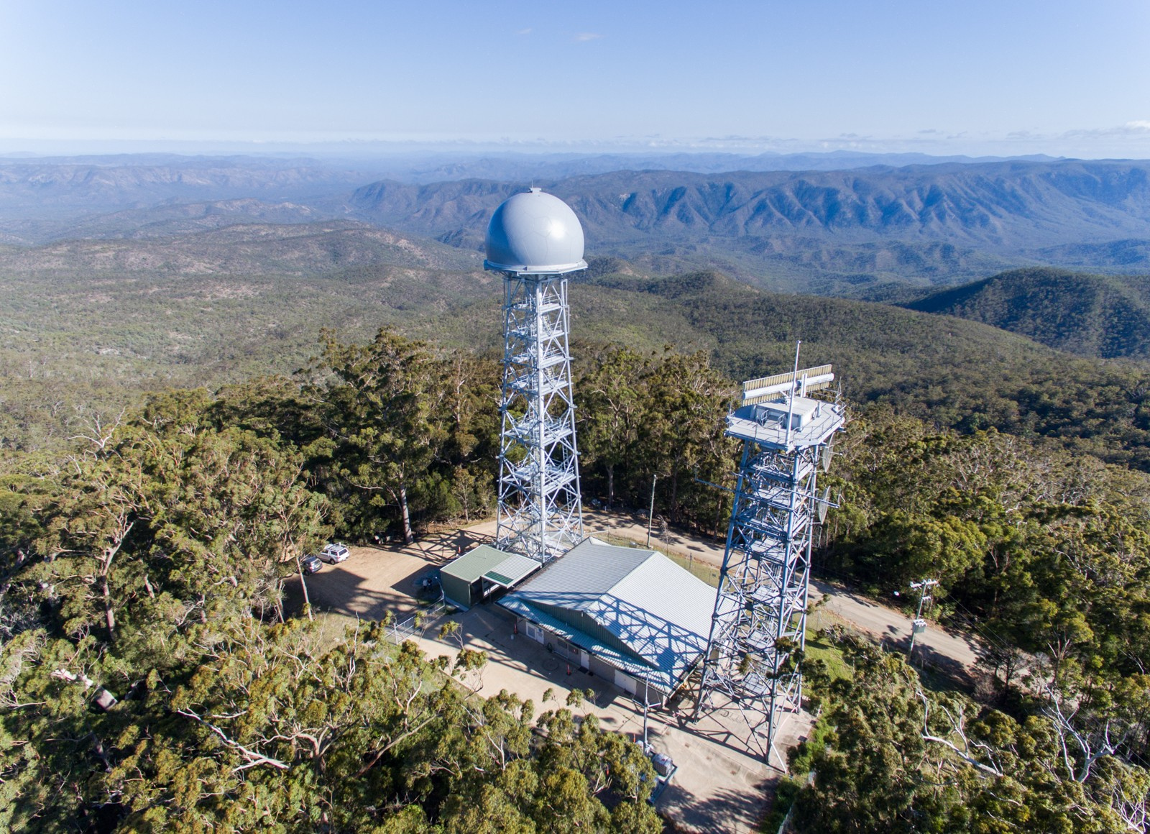

Figure 13 Indra MSSR Radar type used in this analysis